SLE-3: Architectural Design (Full C4 Model)
Course: 02AML204 – Introduction to Artificial Intelligence
PRN: 25UAM087
Name: Pranav Gajanan Revankar
Division: B
Date: 04 October 2026
GitHub Link (optional): https://github.com/pranavrevankar33-ctrl

1. System Title & Short Description
System: 8-Puzzle Solver using BFS and DFS — the same 8-puzzle search system that was profiled in SLE-2.
The system takes a fixed start state and goal state for a 3x3 sliding-tile puzzle and searches for the goal using two uninformed search algorithms, Breadth-First Search (BFS) and Depth-First Search (DFS). For every run it counts the nodes expanded and measures the average execution time over 3 runs. It solves the problem of comparing two search strategies fairly on the exact same puzzle, start state and move order. SLE-1 built a rule-based chatbot agent, SLE-2 measured this search code, and this SLE-3 documents the architecture behind it.

2. Context Diagram (Level 1)
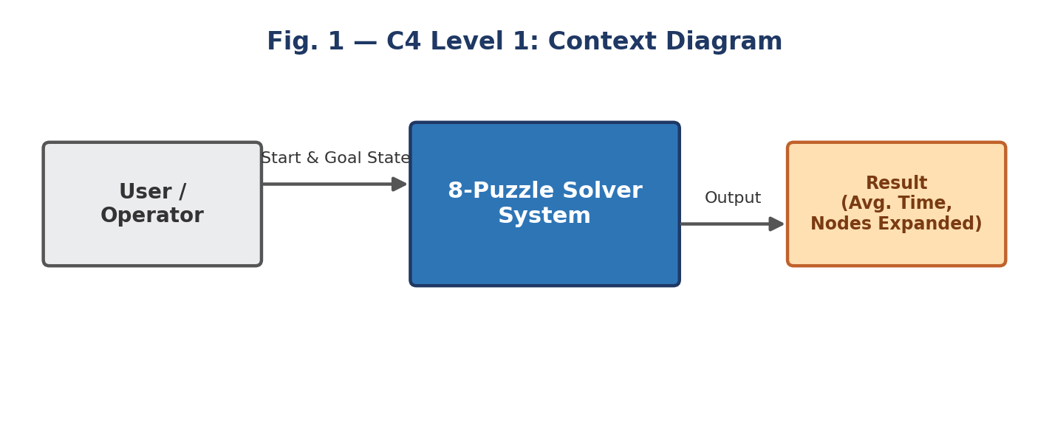
Fig. 1 — C4 Level 1: the 8-Puzzle Solver System and the world around it.
The User / Operator gives the system a start state and a goal state and receives back the average execution time and the number of nodes expanded for each algorithm. The system has no external system, database or network dependency — it only uses Python's own standard library (time, collections), so no outside box is drawn besides the user.

3. Container Diagram (Level 2)
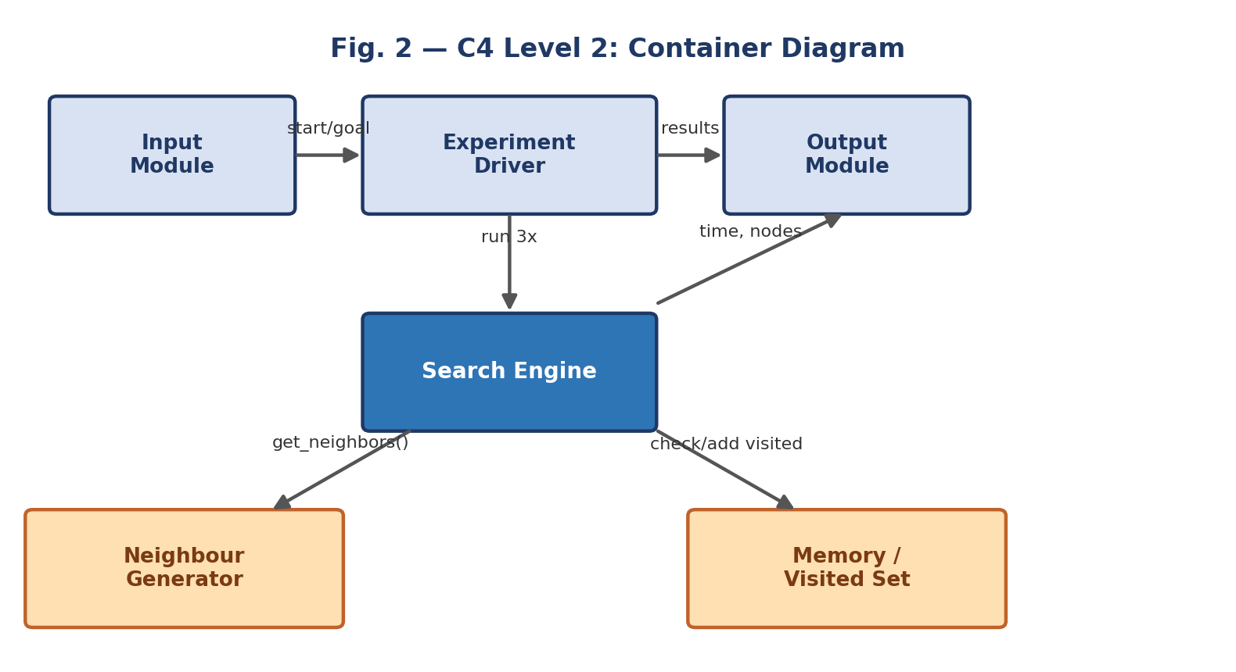
Fig. 2 — C4 Level 2: the six main building blocks of the system.
- Input Module: holds the fixed INITIAL_STATE and GOAL_STATE tuples.
- Experiment Driver: run_experiments(); calls each solver 3 times and times every run with time.perf_counter.
- Search Engine: solve_bfs() or solve_dfs(); expands states and counts nodes_expanded.
- Neighbour Generator: get_neighbors(); shared by both algorithms so the comparison stays fair.
- Memory / Visited Set: the visited set inside each search that stops states being expanded twice.
- Output Module: prints the final average-time and nodes-expanded summary.

4. Component Diagram (Level 3)
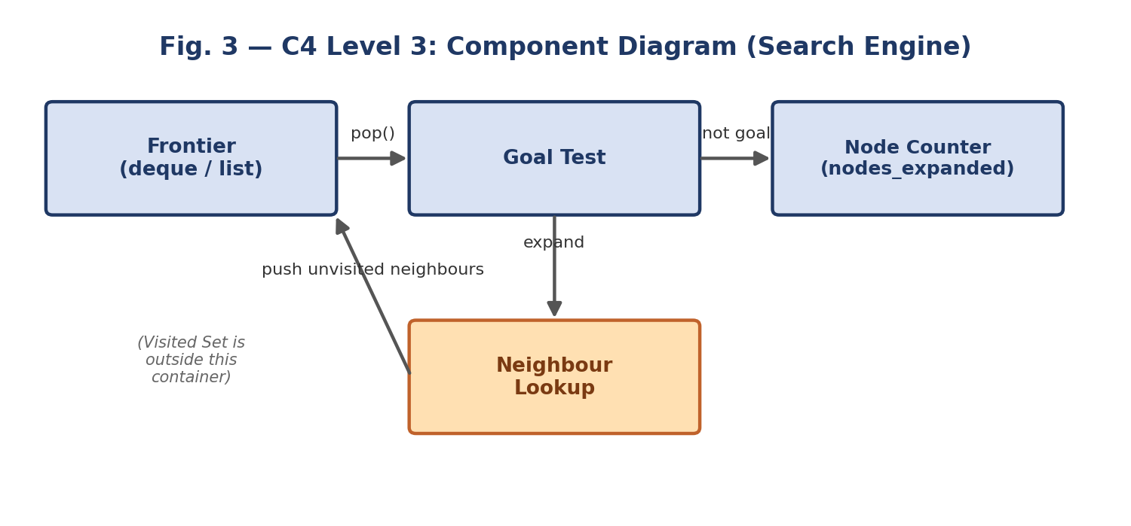
Fig. 3 — C4 Level 3: components inside the Search Engine container only.
The Search Engine is the most important container, so only its internals are drawn. The Frontier (a deque for BFS, a list for DFS) gives up the next state, which the Goal Test checks. If it is not the goal, the Node Counter increments and the Neighbour Lookup is called to get the next states, which are pushed back onto the Frontier if not already visited. The Visited Set itself lives in the Memory container, not inside Search Engine. Note: this implementation only counts nodes and does not reconstruct an actual move path, so no Path Reconstructor component is shown.

5. Code Level Overview (Level 4)
Name | Kind | Responsibility (container)
INITIAL_STATE / GOAL_STATE | tuple | The fixed start and goal 8-puzzle states (Input Module).
get_neighbors(state) | function | Returns the valid Up/Down/Left/Right neighbour states of a given state (Neighbour Generator).
solve_bfs(start, goal) | function | Breadth-first search using a FIFO queue (deque); returns nodes expanded (Search Engine).
solve_dfs(start, goal) | function | Depth-first search using a LIFO stack (list); returns nodes expanded (Search Engine).
run_experiments() | function | Runs each algorithm 3 times, times it with time.perf_counter, and prints the results (Experiment Driver / Output Module).

6. Design Decisions
get_neighbors() is written once and shared by both solve_bfs() and solve_dfs(), so the two algorithms differ only in the Frontier's data structure (deque vs list) and nothing else, keeping the SLE-2 comparison fair. A visited set is used instead of storing full paths, since the puzzle's move graph has cycles (a move can be undone) and would loop forever without it. Timing lives only in the Experiment Driver, so measuring the algorithms never changes the search logic itself. There is no Heuristic Module, since BFS and DFS are both uninformed; an A* version could later add one as a new component inside Search Engine.

7. AI Contribution Note
- AI tools used: Gemini and ChatGPT (SLE-1/SLE-2 code), and Claude.
- What AI helped with: suggested the C4 structure for this 8-puzzle system, drafted the four levels, produced the diagrams, and wrote the draft explanations from my SLE-1 and SLE-2 reports.
- What I did myself: chose BFS/DFS 8-puzzle as the system, reviewed every diagram and description against my own SLE-2 code (bfs_dfs_8puzzle.py), and checked that the container and function names match what I actually implemented.

8. Conclusion
C4 showed me the same system at four levels of detail: Context shows who uses it, Container shows its main parts, Component opens up the Search Engine, and Code lists the functions that implement it. Drawing it made it clear that BFS and DFS share almost everything — the same neighbour logic and the same visited-set idea — and differ only in how the Frontier is handled, which is exactly why the SLE-2 results came out the way they did. I also learned that a small, readable diagram with a few boxes explains a design better than a crowded one.

